**Storing SQL data in Azure**

To host sql solution on cloud

1. IAAS –

* we build a VM
* On top of VM we install SQL server instance
* We use our application server and and connect to the sql instance

We can create more then one VM With full control. But we are responsible for VM, its operating system, backups.

1. PAAS-

We directly get access to database, so if we have an Application we can directly connect to it.

La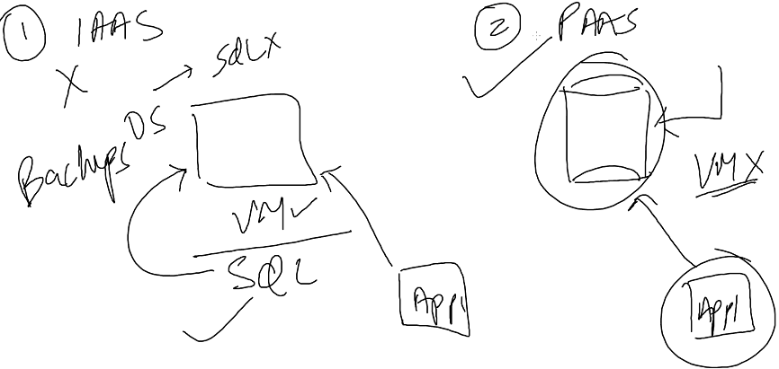

Labs:

Lesson 1- Azure SQL database

* Create SQL database
* Sample database
* Configure Server
* Pricing planes, DTU -database transaction plan(input and output speed control)

Storage- 4 DB

* Create
* Copy server name and Connect this to sql server management

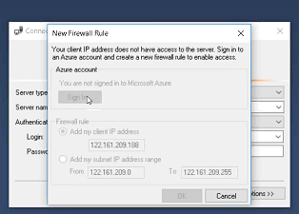

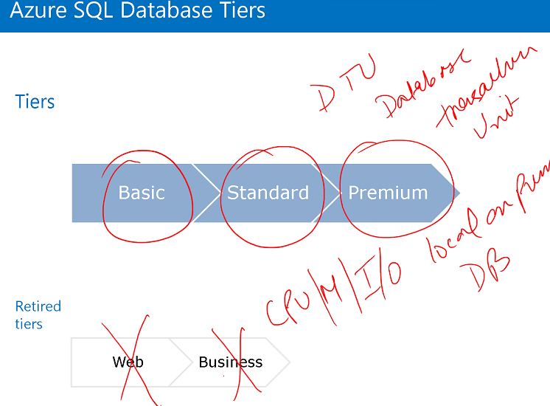

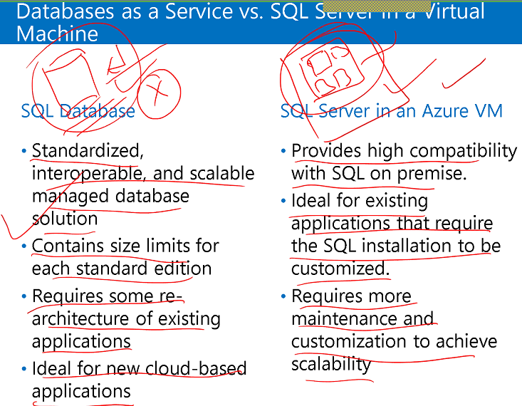

In SQL Database, we can have single database and can access that only where as in SQL Server in Azure we will have an instance in which we can create multiple databases.

Backup happens automatically, access to VM.

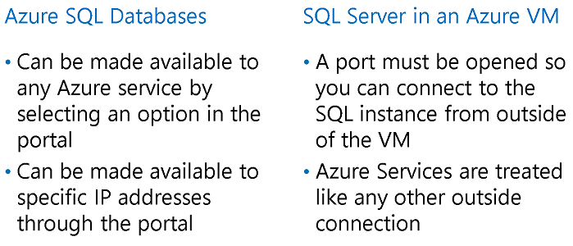

Architecture of Azure SQL Server:

We have Instance in sql database in master database in our machine. We create database in the server and can access that database only. We don’t have access of MDB or of the instance.

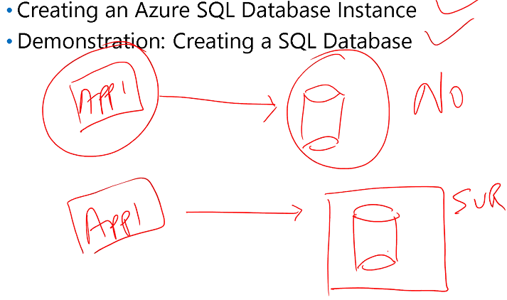

We cannot connect App1 to database directly, we will connect to Cloud server where our database is hosting.

First we create a server in cloud and attached database. This server is a logical entity and its free we just pay for database.



Labs:

1. Create sql server – it’s a logical entity we don’t pay for it
2. Create sql database
3. Access this using visual studio
4. Open sql server object explorer
5. Manage sql subscription
6. Close
7. Add sql server - Connect to cloud server

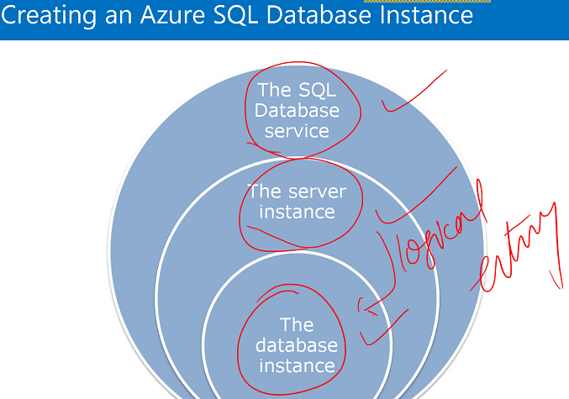

When we use SQL Azure we get access to DB not SQL server. We create logical SQL server and add dB to it.

**Azure SQL Database Tools**

* SQL Server Management Studio
* Migration Tools

SQL Server Management Studio

* First, we must add our IP address to the firewall rules of allowed IP addresses.

This is done in the configuration page for the server

* The Server Name is viewable on the dashboard of the database or the server
* Use SQL Server Authentication and the username/password you set up in the creation of the server.

Windows Firewall filters incoming traffic to help block unwanted network traffic. Optionally, Windows Firewall can also filter outgoing traffic to help limit the risk of malware.

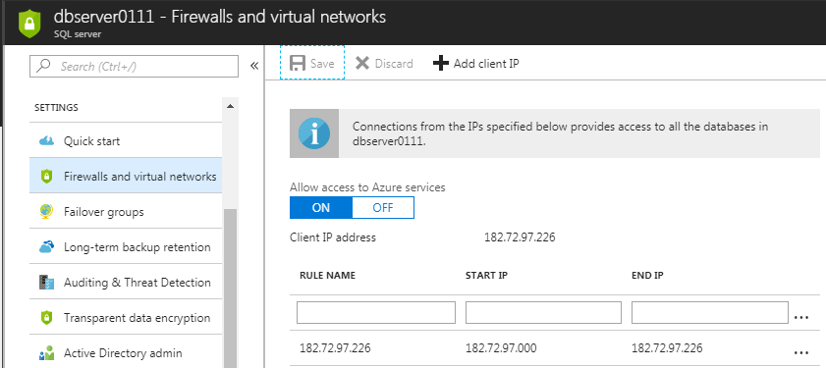

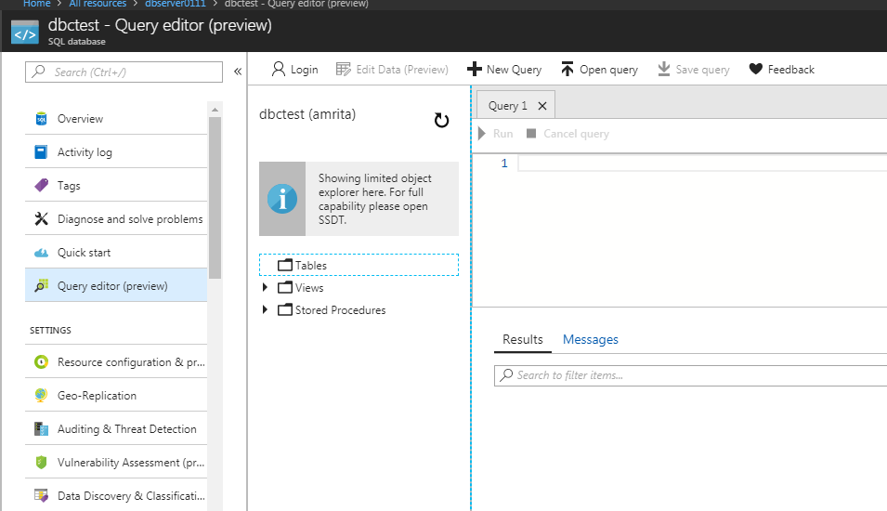

Using Query editor we don’t need to login using SSMS

**How to add Active Directory admin:**

1. Select sql server
2. Configure Active directory admin
3. Set admin

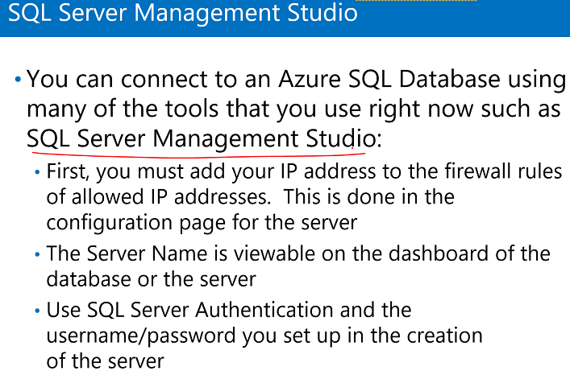

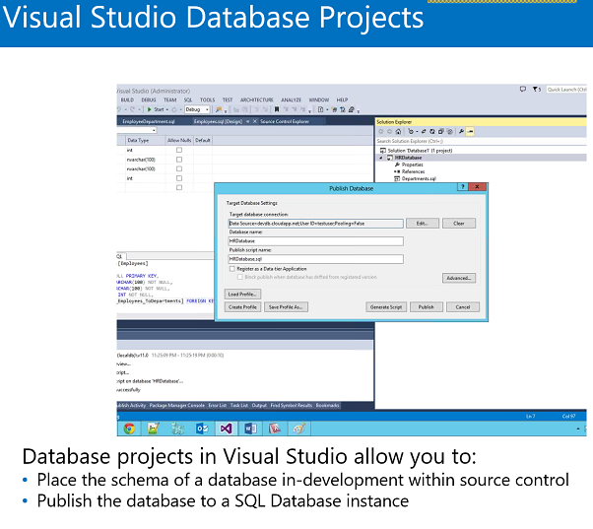

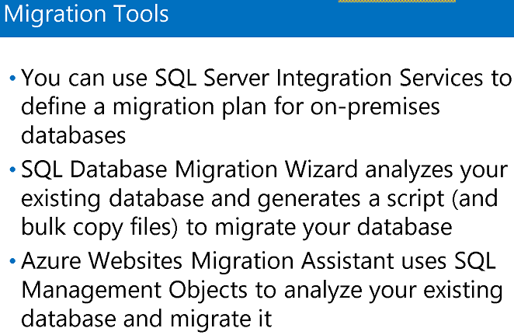

Secure and Recovering:

1. By default sql server will backup automatically.

* Sql database – restore – point in time (for 35 days) / long term
* Long term – create backup volt(maximum 10 years)

1. HADR – high availability and disastrous recovery
2. Built – in replicas
3. Database copy – one copy
4. We can import and export

Labs:

* Selet sql database –export - storage account – create container – select the container – password
* Show the files:

SQL storage – blobs – sql export - .bacpac file

* Creating Automation Account

Automation Account – RunBooks – backup sql blobs –import – schedule this

* Geo replication

Select database – Geo-replication – West US – target server – configure pricing – ok

**Azure SQL Database Geo replication**

**Active geo-replication is available for premium SQL database instances:**

* This feature is asynchronous by default and guarantees that replicas will be eventually consistent.
* You can replicate transactions to as many as four copies of the database.
* Replicas can exist in different regions for geo-redundancy.

**You can use the replica of the database as a read- only data source in load- balancing scenarios**

* Example: An application uses the primary database for line-of-business functionality and the replica for reports

**Elastic Pool**

Suppose I am using four databases with DTU, storage and server or space and I am paying for each database particularly, so I have to reduce the cost of use. So that I pay least possible amount.

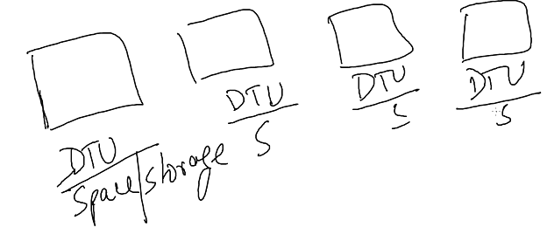

So I will create one pool of resources and this pool will have 2000 DTU and 250 Gigs of space and I can assign these database in this pool and these databases can utilize this DTU and these space collectively.

Normally we pay individually for each database. So now I can pay for the pool and assign databases to this pool.



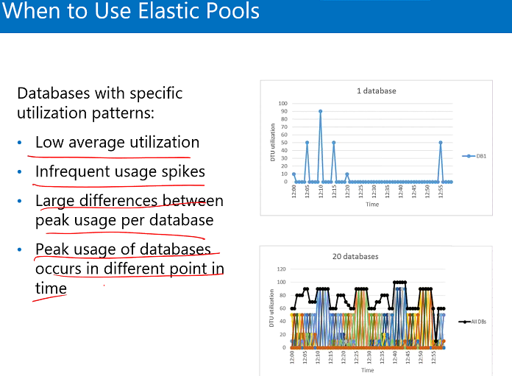

**Labs:** Elastic pool

1. Select SQL elastic pool
2. Create server with username and password
3. Pricing tier
4. Configure pool dtu = 200, space 250 gb
5. Create
6. Now start adding database

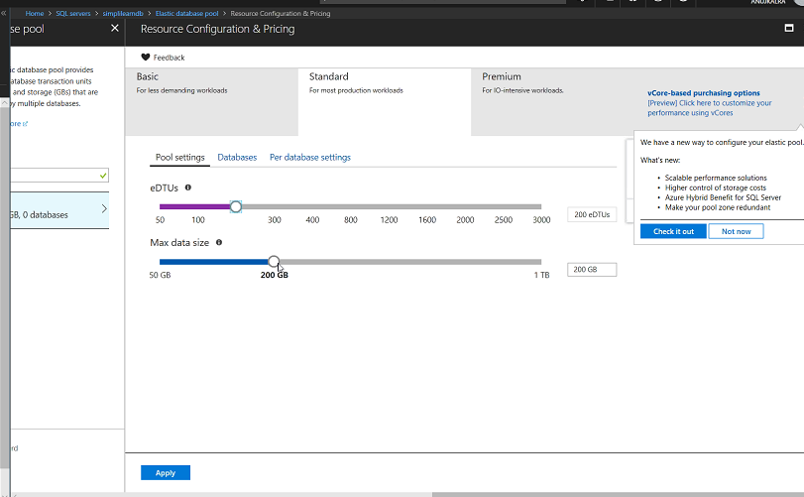

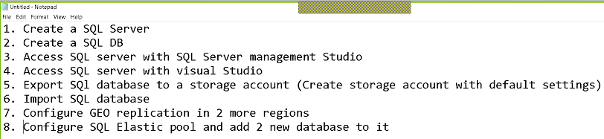

**When to use SQL in VM and When to use SQL Azure?**

If our application is old and if we want to move then we can use SQL on VM.

If we need reporting services then we should use SQL on VM, we can install all those additional features on VM

SQL Azure doesn’t have these features.